Science in China Series F:Information Sciences 2006 Vol.49 No.6681—701 681

DOI:10.1007/s11432-006-2030-6

Internet-based virtual computing
environment (iVCE):Concepts and architecture
LU Xicheng¹²,WANG Huaimin²&WANG Ji²
1.National Laboratory for Parallel and Distributed Processing,Changsha 410073,China;
2.College of Computer,National University of Defense Technology,Changsha 410073,China Correspondence should be addressed to Lu Xicheng(email:xclu@nudt.edu.cn)
Received April 15,2006;accepted September 4,2006
Abstract Resources over Internet have such intrinsic characteristics as growth, autonomy and diversity,which have brought many challenges to the efficient sharing and comprehensive utilization of these resources.This paper presents a novel approach for the construction of the Internet-based Virtual Computing Environment (iVCE),whose sig- nificant mechanisms are on-demand aggregation and autonomic collaboration.The iVCE is built on the open infrastructure of the Internet and provides harmonious,transparent and integrated services for end-users and applications.The concept of iVCE is presented and its architectural framework is described by introducing three core concepts,i.e.,autonomic element,virtual commonwealth and virtual executor.Then the connotations,functions and related key technologies of each components of the architecture are deeply analyzed with a case study,iVCE for Memory.

Keywords:resource,aggregation,collaboration,virtual computing environmentInternet.

1 Introduction
With the fast development and wide application of computing and network technolo- gies,Internet has become an important information infrastructure for modern society[1-31 Nowadays there are vast kinds of resources over Internet,including instruments,infor- mation and applications,etc.Many applications of the national informatization of China, such as e-business,e-government,e-science and e-military,have brought exigent re- quirements for the sharing and utilizing of networked resources.Lots of efforts have been made to solve this problem during recent years,but it is still prominent and urgent in a whole to achieve satisfied solutions.For example,the usage ratio of sharing resources in the Internet is significantly low⁴]while a large number of resources are abused.There

682 Science in China Series F:Information Sciences

seems a long way to the harmonious,trustworthy,and transparent network computing environment,which was envisioned by Licklider⁵,the famous forerunner of the Internet.
The effort for effective sharing of networked resources has been making since the slo- gan “network is computer”was proposed.In the middle and late of 1980s,the practice of distributed operating systems⁶,whose typical examples are Amoeba and Mach,showed that it is hard to build a unified and global view of all resources in the open network computing environment and the resource management mechanisms in the traditional computer operating systems are no longer effective in the network environments.At the beginning of 1990s,people turned to studying the distributed computing environment to support the management of specific resources (e.g.,data resources)for specific applica- tion patterns (e.g.,Client/Server)by distributed mechanisms (e.g.,inter-operating mechanism7,8)and got many exciting results.Since the middle of 1990s,the Web and search engines have achieved the great success,which inspires people to seek new ways for sharing application resources in wider domains.After the new century came,many new technologies,such as web services and grid computing,are flourishing.
While summarizing the researches and applications during the past twenty years,we notice that there are differences in essence between the Internet environment and the tra- ditional computer environments.A basic conclusion is that the traditional resource man- agement pattern in a single computer will be no longer suitable for the Internet.The computing environment that does not adapt well to the intrinsic characteristics of the Internet is the bottleneck for the effective sharing and utilization of the Internet resources. We must seek novel concepts and mechanisms to solve this problem.
In this paper,we propose the concepts and architecture of Internet-based virtual com- puting environment (iVCE),whose innovative mechanisms are on-demand aggregation and autonomic collaboration.The remainder of the paper is organized as follows.Section 2 discusses the intrinsic characteristics of Internet resources and the challenges to the resource management.Section 3 presents the concept of aggregation and collaboration in iVCE,and discusses the key scientific problems that should be solved to construct the iVCE.Section 4 describes the three core concepts,i.e.,autonomic element,virtual com- monwealth and virtual executor,and presents the architecture model of the iVCE based on them.Section 5 shows a case of the iVCE and analyzes the connotations,functions and related key technologies of each components of the architecture with the case.Sec- tion 6 introduces the related work and Section 7 concludes the paper.

2 Intrinsic characteristics and challenges of the Internet resources
The success of the traditional management methods for computer resources is due to
the three fundamental assumptions:1)There is an explicit boundary of the managed re- sources;2)the global control over resources;and 3)there is a uniform description for all resources.However,the above three assumptions do not hold on the management of the Internet resources.The past practice shows that the traditional resource management methods can no longer be applied to the Internet resource management.
In summary,the Internet resources have three tightly interrelated intrinsic characteris-

Internet-based virtual computing environment (iVCE):Concepts and architecture 683

tics,namely growth,autonomy,and diversity.
(1)Growth. Growth is referred to the dynamic characteristics on the ever-expanding scale of the Internet resources,and the ever-changing of the relationship among the re- sources.Internet is a constantly growing open system,where its geographical coverage is expanding,and large numbers of distributed and heterogeneous resources are updating and expanding from time to time.With the development of Internet applications,the re- sources and their relationship are evolving dynamically,and the corresponding resource information (i.e.,description of the resource attribute information)will also expand and change timely.The growth characteristic of the Internet makes it difficult to determine the scope of resource management.
(2)Autonomy.Autonomy is referred to the characteristics on local autonomy and autonomic decision of the Internet resources.For example,many Internet resources be- long to a specific organization or individuals,and the resource provider can decide to provide its resources to the resource consumer or not.The global control of resources is hardly applied for the environment and collaboration becomes a major way of resource sharing.However,there is lack of effective mechanisms for collaboration among local autonomous resources on the Internet,and it is difficult to aggregate those resources to carry on large-scale applications effectively.The relative independency of the resources affects their comprehensive utilization seriously.
(3)Diversity.Diversity is referred to the characteristics on the various differences among the attributes of the Internet resources.These differences increase the difficulties of unified modeling and management of the resources.For example,the Internet re- sources include not only information and data resources,but also applications and service resources,as well as physical resources,such as computers and instruments.These re- sources have significant differences in types and attributes,and it is difficult to give a comprehensive and consistent description for them.This has brought great difficulties for resource organization and management.
The intrinsic characteristics of the Internet resources have brought enormous chal- lenges for the effective sharing and comprehensive utilization of the resources.Through years of research and practice,it is recognized that it is difficult to follow the traditional centralized-control way to manage these growing,autonomous and diverse networked resources.We must break through the current mechanisms in the computing environ- ments.We notic that the key to achieve the breakthrough lies in the innovation for the resources management mode that can comply with the characteristics of the Internet re- sources.Therefore,to build iVCE over Internet,we must carefully realize two kinds of transitions of resource management in the following two aspects:1)the transition from the attempt to hold all resource information to on-demand aggregating resources based on local information;2)the transition from the traditional centralized-control manage- ment of all resources to the sharing and comprehensive utilization of resources by auto- nomic collaborations among the distributed autonomous Internet resources.

3 Concepts and key scientific problems of iVCE
To achieve the effective sharing and comprehensive utilization of the Internet re-

684 Science in China Series F:Information Sciences

sources,we present the Internet-based Virtual Computing Environment (iVCE),whose core mechanisms are on-demand aggregation and autonomic collaboration of networked resources.
Firstly we present some concepts in the iVCE.Aggregation is referred to the process of efficiently acquiring,collecting,organizing and comprehensively utilizing the property information of networked resources.Collaboration is referred to the process of interac- tion,synchronization and computation of multiple resources for the accomplishment of the common tasks.The iVCE is built on the open Internet infrastructure to provide a harmonious,trustworthy,and transparent integrated service environment for the end-users and applications.The iVCE uses two core mechanisms,i.e.,on-demand ag- gregation and autonomic collaboration,to achieve efficient sharing and convenient coop- eration of networked resources.The resource management in the iVCE is mainly achieved through the union of aggregation and collaboration.Therefore,the key of the construction of the iVCE is to design novel aggregation and collaboration mechanisms that can adapt to the intrinsic characteristics of Internet resources.
In the following subsections,we will discuss the key scientific problems for the con- struction of the iVCE.
3.1 On-demand aggregation in the open Internet environment
The first key scientific problem for the construction ofthe iVCE is how to on-demand collect,organize and comprehensively utilize resource information based on the local information,and form a relatively stable resource view,which can satisfy the require- ment of tasks and support its accomplishment.
The intrinsic characteristics of growth,autonomy and diversity of the Internet re- sources cause that the resource allocation can only be made to maintain the relatively stable view when resources varying.In the open and dynamic Internet environment,it is almost impossible to acquire the global and consistent resource property information. Therefore,the first important challenge for the construction of iVCE is to on-demand build a relatively stable computing view of resources,which can adapt to the open Inter- net environment.
To adapt to the characteristics of the Internet environment and its resources,the re- source aggregation mechanisms in iVCE should support flexible and various resource sharing models,including the tight-coupled sharing model,the strong-committed sharing model,and the hybrid resource sharing models that contains multiple coupled modes and various degrees of commitment.And the range of resource aggregation may vary from intra-organization,inter-organization to the Internet.The key technologies that the on-demand aggregation mechanism in iVCE should provide include the distributed and self-organized description,publication and discovery approaches of the resource infor- mation,as well as the organizing and scheduling methods of various resources.
3.2 Autonomic collaboration among distributed autonomous resources
The second key scientific problem for the construction of the iVCE is how to support and perform the collaboration among autonomous resources.It is expected to construct

Internet-based virtual computing environment (iVCE):Concepts and architecture 685

the predictable,assessable and adjustable collaboration mechanisms and operating envi- ronment to efficiently share and comprehensively utilize resources to accomplish the common task.
In the open Internet environment,the diversity of resources leads to different collabo- ration patterns of various autonomous resources.There are usually some uncertainty with the collaboration environments,objects and protocols,and there might exist inconsis- tency between the local goal and the common goal during the complex collaboration among multiple autonomous resources.All the above properties bring much complex requirement on both the collaboration ability of autonomous resources and the operating mechanisms of the network computing environment.To support dynamic,flexible and autonomic collaboration among resources in the open dynamic environment and then form the core operating mechanisms of the iVCE,the resources should have been fur- nished with more powerful ability of autonomic decision-making and self-adaptation. Meanwhile,the operating environment should also provide support for protocol man- agement and evolution.
The iVCE needs to support various collaboration mechanisms,including the simple syntactic-level interactive and the semantic-based collaboration mechanisms.The iVCE also needs to support various collaboration patterns,ranging from the statically prede- fined patterns to autonomic,dynamic and flexible patterns.Therefore,the key properties that the autonomic collaboration mechanisms in the iVCE should provide are shown as follows:the self-management and dynamic decision of resources,constraint satisfaction of collaboration under complex conditions,the interaction of collaboration patterns in the open environment,the management and evolution of collaboration protocols,and the behavior incentive of autonomous resources,etc.
3.3 Computational properties of the aggregation and collaboration
The third key scientific problem for the construction of the iVCE is how to perform the mathematic description of the computational properties of the aggregation and col- laboration processes in the iVCE,as well as the related methods about measurement, analysis,evaluation,optimization and provision of these properties.
The Internet has the characteristic of openness and its resources have the characteristic of autonomy.There will be many fundamental topics needed to be investigated in re- source aggregating and collaborating environment,such as incompleteness,inconsistency and uncertainty,etc.Therefore,we need to theoretically understand the static and dy- namic properties of the aggregating and collaborating processes in the iVCE,including the complex-system property emerged during the large-scale collaboration.This is also the basis for the trustworthy assurance.It is difficult for the traditional computational theory and methods to reveal and process the essential of the computation that takes the interaction as the basic elements.It is also very difficult for the traditional computational theory and methods to give the qualitative and quantitative description for the computa- tional properties of the aggregation and collaboration processes in the iVCE.Meanwhile, with the increasing importance of the trust in the open environment,the security,trust
and QoS techniques,as well as their assurance mechanisms have become the vital part of

686 Science in China Series F:Information Sciences

the iVCE.

4 The architecture of iVCE
In this section we will explore solutions to the key scientific problems of the iVCE from architectural perspective,including:1)building the model of resources to describe their autonomy;2)building the community with common interests to support resources' on-demand aggregation;3)building the distributed execution mechanisms to support resources'autonomic collaboration.Correspondingly,three important concepts of the iVCE are proposed,i.e.,autonomic element,virtual commonwealth and virtual executor.
4.1 Core concepts
(i)Autonomic elements.The autonomic element is a basic resource management unit in the iVCE and it is a resource manager with the ability to act autonomously.In the internal structure,an autonomic element consists of a sensor,a behavior-driven engine and an executor,as shown in Fig.1.The sensor provides the perception ability to obtain the presence of its environment and managed resources.It can acquire the change of the environments and the operating status of resources(e.g.,the variation of the free space of storage resources,and the variation of the load of computing resources,etc.).The behav- ior-driven engine makes decision based on the perceived environmental and resource information and the executor performs the final action,which will affect not only the status of the resources,but also the environment they situate in.The sensor,the behav- ior-driven engine and the executor form a control loop,which is the core of the realiza- tion ofresource autonomy.
The decision of behavior-driven engine mainly depends on the two pieces of informa- tion in the autonomic element,i.e.,the knowledge state and the behavior policy.The knowledge state includes the autonomic element's perception (or model)of the environ- ment and its historical experience,and the behavior policy includes the possible deci- sion-making actions.The behavior-driven engine makes the decision according to its en- vironmental stimulus perceived from the sensor,as well as its cognition of the environ- ment and its own experience.And then it performs reason and choice with certain be- havior strategies and makes the decision to drive the executor.
To provide transparent and consistent resource services,the iVCE uses the autonomic element to abstract and encapsulate the Internet resources into dynamic autonomic ele- ments.That is not only a reflection of the resources'own autonomy,but also an effective shielding and adaptation of resources'diversity and evolution.Autonomic element is the most important abstract of resources'virtualization,and its concepts and ideas make it a cornerstone of Internet resources'on-demand aggregation and autonomic collaboration in a structural and methodological way.One autonomic element could abstract and encap- sulate several resources,be granted with the abilities of dynamic perception,autonomous decision-making and collaboration.Autonomic elements could be combined together, and one autonomic element could consist of several elements.Autonomic elements pro- vide meta-information of (resources')on-demand aggregation,and support resources'

Internet-based virtual computing environment (iVCE):Concepts and architecture 687

access and interaction through a consistent interface.From the life cycle perspective,the autonomic element is persistent and dynamic,could be dormant or awaken in its life cy- cle.From the modeling perspective,the autonomic element is the abstraction of Internet resources.From the technical point of view,the autonomic element is the virtualization and the autonomy of the Internet resources.

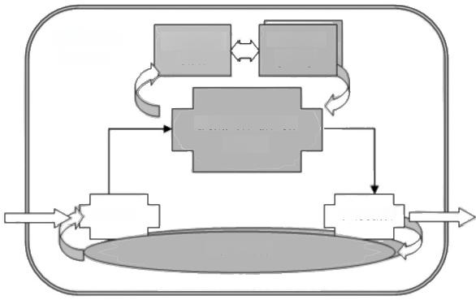
Autonomic element
Behavior policy
Knowlege
state

Behavior-driven engine
Environments
Environmients

Sensor Executor
Resources

Fig.1.Internal structure of autonomic elements.

Due to the diversity of applications and the heterogeneity of resources in the iVCE, different applications have different requirements for the resource sharing and collabora- tion capabilities of the iVCE.For example,some applications only need the reactive ca- pability of resources in the iVCE,such as website applications,while other applications make comprehensive analysis and judgment on the basis of resources'log and history information of sharing.Therefore,autonomic elements can have different internal struc- tures.We can divide the autonomic elements into two types by the complexity of their internal control models.The automatic element of the first type only has the simple reac- tive policy and it acts reactively on the basis of external environmental stimulus(such as service requests).This type of the elements only maintains the whole behavior policy and its knowledge state is relatively degenerated.The traditional websites are typical exam- ples of this type.The second type of autonomic elements maintains certain knowledge and state information.The element of the second type can perceive and analyze the state of resource and environment,and then make complex decision through modeling,ana- lyzing,reasoning and other internal mechanisms.The latter type will be the primary unit to support autonomic collaboration in the iVCE,because it has more autonomic and in- telligent features.
(ii)Virtual commonwealth. Due to the growth of Internet resources,it is difficult to get all the resource information.Thus,we must aggregate the resources by local informa- tion based on the requirements of the task.The aggregation of the resources should be carried out in a certain scope.In the iVCE,only the autonomic elements with the same interest and requirement should be selected into the scope of resource aggregation. Therefore,we propose the concept of virtual commonwealth.

688 Science in China Series F:Information Sciences

A virtual commonwealth is a set of autonomic elements which have the same interest and obey the common principle.In the virtual commonwealth,each autonomic element may act as different roles.For example,some of the autonomic elements act as the re- source providers,some of them act as the consumers,and some may become the manag- ers of the resource management and scheduling.Although the roles are different,the autonomic elements in the same virtual commonwealth are consistent with the resources they are considering.For example,the autonomic elements in the virtual commonwealth for the sharing of storage resources will play different roles with the common interest of storage sharing.Indeed,an autonomic element may belong to multiple virtual common- wealths.For instance,an autonomic element providing storage resources may provide computing resources at the same time.
In order to perform the task,the virtual commonwealth should provide certain meta-information management infrastructures,and corresponding resource information publication and discovery mechanisms.The resource aggregation is held in the virtual commonwealth through some of the meta-information management infrastructures.
The scope and composition relationship of the virtual commonwealth is illustrated in Fig.2.There are several different virtual commonwealths in the iVCE,and each of them is only interested in a certain type of resources.Each autonomic element in the iVCE should join at least one virtual commonwealth,and register in the meta-information management infrastructure of the virtual commonwealth.The scope of the virtual com- monwealth can be dynamic.An autonomic element should first join a virtual common- wealth when it wants to join the iVCE and an autonomic element will exit the iVCE when it exits all virtual commonwealths.
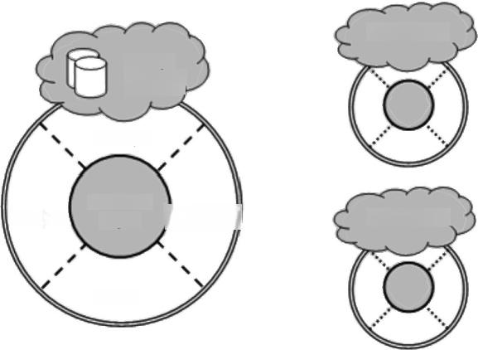
CPU sharing
Storage sharing

Manager

Meta-info
Mgmt Consumer

Others
Data sharing
Provider
Fig.2.The example of virtual commonwealths.
(iii)Virtual executor. In the runtime of the iVCE,it needs to select and request the services of corresponding autonomic elements based on the task requirement and bind the autonomic elements and tasks dynamically.One task may require several autonomic elements to provide services,and one autonomic element may provide services to several tasks.To effectively support the performance of task objectives,the iVCE should manage

Internet-based virtual computing environment (iVCE):Concepts and architecture 689

and coordinate the executing state of autonomic elements.
The virtual executor of a task refers to the whole state space combined with autonomic elements involved in the task.From the modeling perspective,the virtual executor is the abstraction of the collaboration process of networked resources.It is the basic operating management unit in the iVCE,and the carrier of the virtualization of executing process. The virtual executor is tightly related to a task.We can get all the management informa- tion of the task,such as the autonomic elements involved in the task and their interaction states.
The virtual executor makes a dynamic task-oriented binding of a group of autonomic elements,and performs the corresponding task through collaboration among the auto- nomic elements.The dynamic binding among the autonomic elements and the task is a task-oriented process of on-demand aggregation and autonomic collaboration.The bind- ing is performed at runtime,and it could be changed in the life cycle of the virtual ex- ecutor.The features of late binding and dynamic binding provide the foundation for the multiple-scale and flexible collaboration among resources.The collaboration process of the autonomic elements in a virtual executor is represented by the state transition of the bound autonomic elements.
The relationship among the virtual executors and the autonomic elements is shown in Fig.3.The iVCE needs to provide a series of foundational services to manage the crea- tion and execution of the virtual executor and perform the state transition and evolution automatically according to the real situations.
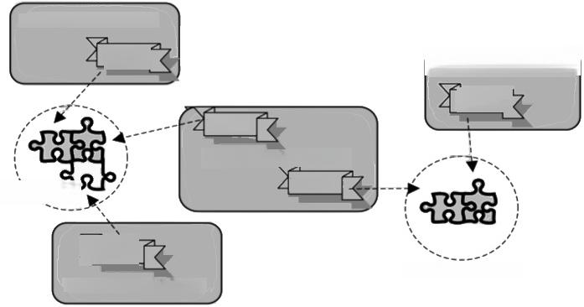
Virtual
Autonomic element A

Task 1[

Task 2
Task 1

Automomic element C
Task 2
executor A

Task 1
Virtual executor B
Autonomic element B
Automomic element D

Fig.3.An example of the virtual executors.
4.2 iVCE architecture description
Based on the above three core concepts,we propose the architecture framework of the iVCE,which is composed of seven parts,as shown in Fig.4.
(i)Resource layer. The resource layer is composed of heterogeneous and diverse networked resources.The resources include not only computers,memory,data and in- formation resources,but also various types of instruments,software application and ser- vices,such as WSRF-resource,CORBA-object,WS-service and J2EE-bean.The iVCE

690 Science in China Series F:Information Sciences

should be able to support the access of various networked resources,and support the effective sharing and collaboration of these resources.
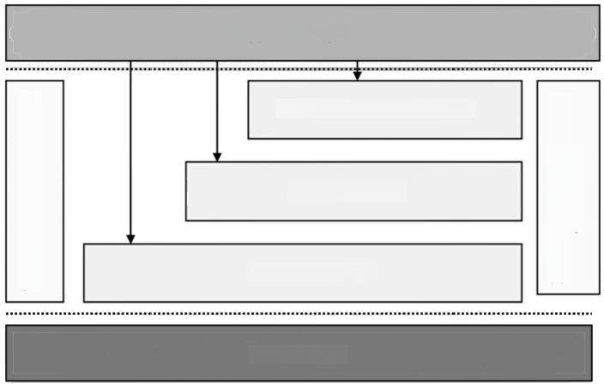
Trustworthy assurance systems
Programming & development
environments
Application layer

Autonomic collaboration layer

Aggregation layer

Virtualization layer

Resource layer
Fig.4.The architecture framework of the iVCE.
(ii)Virtualization layer.The virtualization layer contains the basic services for the creation and management of the autonomic elements.The layer has the capability to en- capsulate the resources into the autonomic elements,in order to make the networked re- sources in the resource layer to be virtual and autonomic.Every autonomic element could be the virtualization or abstraction of one or several networked resources and provide complex or simple services.For example,the autonomic element could be the abstraction of one single storage system,and it could also be the abstraction of several cooperating storage systems.In the latter case,we need to study the provision and virtualization of storage resources to provide a unified storage service with multiple storage systems.The virtualization layer can use various methods to construct the autonomic elements.No matter how complex or simple the encapsulation technology is,and no matter how strong or simple the services provided are,the autonomic element is only one of the basic units in the iVCE.It has some common characteristics,such as the unified description,encap- sulation,access methods and somewhat autonomic decision-making capability.
The virtualization layer needs to support the provision and abstractive encapsulation of networked resources in order to make the resources be virtual and autonomic.The layer should provide the following key technologies:(a)the provision and virtualization tech- nologies of networked resources;(b)the consistent description and modeling technolo- gies of heterogeneous resources for the abstractive encapsulation of resources;(c)the composition and implementation technologies of the autonomic elements,such as the description of the elements'internal state,and the design of corresponding algorithms to enable the autonomic elements perceive,analyze and execute;(d)the access interface and interaction protocol technologies of the autonomic elements for the uniform access
of one single element;(e)the runtime management technology of the autonomic ele-

Internet-based virtual computing environment (iVCE):Concepts and architecture 691

ments for the life cycle management.
(iii)Aggregation layer. The aggregation layer needs to support the creation and management of the virtual commonwealth.It organizes and manages the meta-informa- tion of the autonomic elements in the virtual commonwealths for effective aggregation according to the task requirements in the virtual commonwealth involved,and timely forms the relatively stable task-oriented resource space and view.For example,the search engines can find the web pages in the websites according to user's requirements.They could be regarded as the preliminary approaches in the aggregation layer for the aggrega- tion of the web page resources in the virtual commonwealth consisted of websites.But the search engines currently only provide the capability of keyword-based search,and have not provided the comprehensive processing of the meta-information of large num- ber of web pages.Thus they did not achieve the on-demand aggregation of the web pages. The semantic web technology rising in recent years is mainly focused on the on-demand aggregation of the web pages,but less involved in the aggregation of other networked resources,etc.
The aggregation layer needs to provide basic services to support the task-oriented on-demand aggregation of various resources.The layer should provide the following key technologies:(a)the analysis and extraction technologies of the static and dynamic meta-information of autonomic elements;(b)the scalable resource modeling theory,and the description technology of the autonomic elements'models;(c)the distributed self-organization registration,publication and discovery technology of the autonomic elements'meta-information;(d)the semantics-based search and matching technology of the autonomic elements;(e)the virtual data and virtual file technology;(f)the resource space model and the time-space consistency maintenance technology,etc.
(iv)Autonomic collaboration layer. The autonomic collaboration layer creates cor- responding virtual executor according to the task requirements,binds the related auto- nomic elements with the virtual executor,and performs the task with the autonomic col- laboration.Transaction management,collaboration mechanisms and service composition are functions the layer should provide.
This layer supports the task-oriented autonomic collaboration.Therefore,the layer should provide the following key technologies:(a)the creation and runtime management of virtual executors according to the task requirements;(b)the dynamic binding of the virtual executor to the corresponding autonomic elements at runtime;(c)the autonomic interaction and collaboration mechanisms among the autonomic elements;(d)the auto- nomic elements-oriented service choreography and orchestration technologies;(e)the united schedule and allocation technology of the autonomic elements which encapsulates various resources;(f)the federal data integration and management technology;(g)the semantic theory of the autonomic collaboration and evolution,etc.
(v)Trustworthy assurance system. The trustworthy assurance system provides the assurance of safety,dependence and credibility for the on-demand aggregation and auto- nomic collaboration behavior of resources in the iVCE to create a safe and harmonious computing environment.The system should provide the following key technologies:(a) the access control and authentication mechanisms within or among the virtual common-

692 Science in China Series F:Information Sciences

wealths;(b)the monitor and exception detection technology of autonomic behavior;(c) the high-availability QoS assurance mechanisms;(d)the reputation management mecha- nisms within the virtual commonwealth;(e)the incentive mechanisms oriented to the autonomic collaboration,etc.
(vi)Programming and development environment. The programming and develop- ment environment provides the facilities and the related development and runtime envi- ronment at the programming language level for development,deployment and operation of the iVCE.The environment consists of a programming language,component libraries, editors,compilers and the runtime platforms,etc.
The programming and development environment can support the development of the iVCE system and its applications.It should provide the following key technologies:(a) the software architecture technology of the iVCE;(b)the pattern-based development model and technology;(c)the programming language to support the development of the iVCE;(d)the application-oriented development toolkit and runtime environment for the iVCE,etc.
(vii)Application layer. The application layer provides various application-level functions of the iVCE for users.
4.3 iVCE characteristics
The iVCE and our research have the following characteristics:
(1)The on-demand aggregation and the autonomic collaboration mechanisms are the core of the iVCE computing environment.In order to adapt to the growth,autonomy and diversity of the Internet resources,the iVCE supports task-oriented dynamic resource aggregation based on the local information and achieves the sharing and comprehensive utilization of resources by the autonomic collaboration among the distributed autonomic elements.
(2)The iVCE can support the autonomy of the resources.The definition and modeling of the autonomic element,which has the capabilities of resource encapsulation,informa- tion perception and decision-making,is presented.And the self-organization and self-management mechanism is selected as the entry point to breakthrough the limits of traditional centralized resource management and adapt to the locality and uncertainty of the Internet resources.
(3)According to the different goal and interest of the autonomic elements,the model of the virtual commonwealth is presented and described as the basic range of on-demand aggregation of autonomic elements.The virtual commonwealth is a group of autonomic elements with the same interest,and it provides corresponding management mechanism for the meta-information ofresources.All the autonomic elements in the iVCE could be divided into various virtual commonwealths.To join in the iVCE,the autonomic element should join at least one virtual commonwealth.And it should quit all related virtual commonwealths to depart from the iVCE.
(4)The concept and model of the virtual executor is presented as the dynamic config- urable runtime management model of autonomic collaboration among resources.The
virtual executor is the runtime unit in the iVCE and it provides a dynamic and configur-
Internet-based virtual computing environment (iVCE):Concepts and architecture 693

able runtime foundation for the implementation of the aggregation and collaboration mechanisms in the iVCE.

5 Case study
Based on the architecture and mechanisms of the iVCE,we have proposed a mem- ory sharing environment:iVCE for Memory 9.Although the iVCE for Memory should be evaluated by more applications,we try to explain it as an example of the implementa- tion of the architecture and mechanisms ofthe iVCE.
5.1 Problem description
Aiming at organizing the memory resources distributed on the Internet effectively,the iVCE for Memory tries to support the computing applications which need a mass of ex- tended memory through sharing the idle memory resources.The basic idea of the iVCE for Memory is that the system tries to find available memory resources with high-speed network connection for the nodes which is lack of physical memory(called “user nodes”). The latter will store and fetch memory pages from the remote memory,and support the completion of the tasks.The functions of the iVCE for Memory provide sharing and in- tegrating for the memory resources widely distributed on the Internet.
In the 1990s,with the development of cluster computing technologies,the memory sharing schemes in the cluster named "network memory"has emerged.Typical network memory schemes could be divided into two classes,one of them tries to provide remote paging device through the remote memory sharing to boost the performance of memory intensive applications;the other tries to use remote memory as the cache of local disk,or use it as a high-speed network file system.The common point of these network memory schemes is that all of them try to share memory resources in the scope of a single cluster, while the iVCE for Memory dedicates to the memory sharing in the scope of the Internet, which should deal with abundant resources and users in large area.Compared with the nodes in a cluster,the Internet resources are large in amount,and distributed in different areas with loose coupling,which means that it is difficult to maintain the global resource information.The Internet resources are usually heterogeneous,e.g.,the size of the mem- ory page which is supported by the hardware may be different,and each node may have different local management policies.The Internet resources also have the characteristics of dynamic and autonomic,which means that the memory resources can withdraw the sharing part due to its local requirements.Therefore,we cannot control and manage all of
the nodes globally.In order to cope with the new problems in memory resources sharing, we should build the iVCE for Memory through the architecture ofthe iVCE described in section 4.
5.2 iVCE for Memory
We encapsulate the heterogeneous memory resources into a uniform unit through the
autonomic element in the iVCE for Memory.The heterogeneity can be shielded by the memory services provided by the autonomic elements.Such autonomic elements provid-

<

694 Science in China Series F:Information Sciences

ing memory services are called “memory elements”.We introduce another type of auto- nomic elements,called “deputy elements”,which act as the deputy of the user node.The deputy elements can search proper memory elements automatically and hand over to the users.The iVCE for Memory creates virtual commonwealth for memory elements,dep- uty elements and their users,which is also called “memory sharing commonwealth”,and each autonomic element is voluntary to join this commonwealth.
The cooperative memory sharing is processed among the user nodes,deputy elements and memory elements.Fig.5 shows a basic process of the collaboration,including the search and subscription of the memory elements,the withdrawal and handover of the memory services.The detailed process can be described as follows.
①A user node finds a deputy element in the memory sharing commonwealth,and starts the deputy service of deputy element.
②The deputy element searches for available memory elements.Suppose that it finds the best fitted memory element A,it will send a subscription message to A.
③Memory element A confirms the subscription.After a while,the user node begins to use the memory service provided by A.It will store some memory pages into the physical memory of A,and fetch them if necessary.
④The deputy element continues to search for more available memory elements.Sup- pose that it finds the memory element B.
⑤A detects that local resource usage is too high;it must withdraw the memory ser- vice in order to insure local usage.A hands over current memory service to B,including all of the user memory pages.A should also inform the user node that its memory service has been handed over.
⑥The user node continues to use the memory service provided by B,and it will not impact on the applications in the user node.Thus,the service is moved seamlessly.

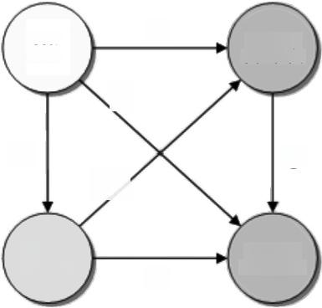
Memory element A
⑥

①
②

Deputy element
Memory element B
User node
③
⑤
④
Fig.5.The working process ofthe iVCE for Memory.

The iVCE for Memory creates a virtual executor for the above collaboration process,
which will manage the states in collaboration.Such a virtual executor is called memory

Internet-based virtual computing environment (iVCE):Concepts and architecture 695

sharing executor.As an instance of the iVCE,the collaboration process of the iVCE for Memory shows the key idea of on demand aggregation and autonomic collaboration in the iVCE.
Table 1 illustrates the relationship of the iVCE and iVCE for Memory in architecture and mechanisms.In order to focus on the key content,we ignore the layer of resource, application,trustworthy assurance,programming and development environment in the architecture of the iVCE.

Table 1 Architecture and mechanisms in the iVCE and iVCE for Memory

iVCE iVCE for Memory
Autonomic collaboration layer | Virtual | executor | Memory sharing executor,which supports the memory resources sharing
Aggregation layer | Virtual | commonwealth | Memory sharing commonwealth,which supports the organizing,publishing and discovery of mem- ory elements
Virtualization layer Autonomic element |  |  | Memory element,the memory service provider  which has the properties of autonomic elements Deputy elements,the memory service searcher  which has the properties of autonomic elements
5.3 Memory elements
In the iVCE for Memory,the resources are idle memory and the host nodes distributed on the Internet.The host node means all kinds of computing systems which can provide idle memory resources.The memory resources are different in memory capacity,access latency,memory page size,addressing and address space,etc.Their host nodes are also different in architecture,instruction set and operating system,etc.The iVCE for Memory shields the heterogeneous through the memory services provided by the memory ele- ments.For example,the page size in different computers may be different,the iVCE for Memory will appoint a basic page size,and all of the operations on the memory pages will use this basic page size as a unit.Note that memory element is not only an encapsu- lation of the memory resources,but also an autonomic element in the iVCE,which transforms the static,passive memory resources into the active,autonomic unit providing the memory service independently.In order to make such a transformation,some parts of perception,action and behavior driven engine should be added to the native memory element.The key parts and their functions of the memory element are shown in Table 2.
As shown in Table 2,the part of perception in the memory element includes the ap- perception from external requirements and the status of memory service.The memory element should select corresponding actions and feed back through the part of action. The selection may be performed by certain policy;it is also called the reactive action engine.In addition,we can add autonomic behavior in it,including the selection of deci- sions and actions using knowledge and consequence algorithm.In conclusion,the mem- ory element can be seen as an autonomic element in the iVCE,it not only encapsulates the heterogeneous of memory resources,but also makes the resources having the abilities of autonomic decision-making and growing-enabled evolvement.

696 Science in China Series F:Information Sciences

Table 2 Key parts of autonomic elements and memory elements

Parts of autonomic elements |  | Parts of | the memory elements | Example of the functions
 |  | Internal | Apperception of the memory element status | Monitor the corresponding host node,probe the CPU and memory usage,network latency and band- width,local operation and exception
Perception |  | External | Receiver of the external require- ments | Apperceive the subscription re- quirement from the deputy element, and the requirement of storing and fetching the pages from the user node
Action |  | Internal | Policy adjust- ment of the  memory element | Adjust the memory capacity for sharing and the service pattern; transform the status of the memory element if necessary
 |  | External | Responder of the external require- ments | Response the subscription require- ment from the deputy element;can- cel the subscription if necessary; response the storing and fetching requirements from the user node; hand over the memory service when exception raised.
Behavior driven  engine | Reactive Policy | Condition-Action library and the part of selecting action from certain condition |  | React and adjust on the internal status;response to the external re- quirements
Behavior driven  engine | Autonomic Knowledge | Expression of belief and ef- fect,problem generator,the part of study,consequence and decision-making |  | Analysis on the user actions and the study of user patterns.  Customize services on different users
5.4 Memory sharing commonwealth
The publishing,discovery and organization of the meta-information for the resources are performed in a certain scope.The concept of "virtual commonwealth"in the iVCE describes the set of autonomic elements which have the common interest and obey the common rules.In the iVCE for Memory,the “memory sharing commonwealth”includes all of the memory elements,user nodes and deputy elements which volunteer to add the commonwealth.Their common interest is the sharing of the memory,as illustrated in Fig. 6.
As shown in Fig.6,the memory sharing commonwealth has the infrastructure of the publishing,discovery and organization of the resources meta-information.Due to the time cost of the searching operation on the meta-information of the resources in WAN, we introduce the deputy elements to help user to search for proper memory elements.The user should first find a deputy element,and the latter will search and subscribe on the available memory elements as required,the on demand aggregation is performed as this. In order to support the sharing and utilizing of the resources,the deputy element should build and keep a relatively stable view of the resources based on the meta-information in the commonwealth,through the demand of the task in some certain scope of time and space.
5.5 Memory sharing executor
Due to the distribution and autonomy of the Internet resources,in order to make the effective collaboration in the condition of autonomy,the “memory sharing executor”acts

Internet-based virtual computing environment (iVCE):Concepts and architecture 697

similar to a workflow mechanism which is built by several autonomic elements through the status set of the task and the task boosting based on the idea of autonomic collabora- tion and virtual executor in the iVCE.All of the user nodes,deputy elements and memory elements act on each other through the memory sharing executor,as illustrated in Fig.7.

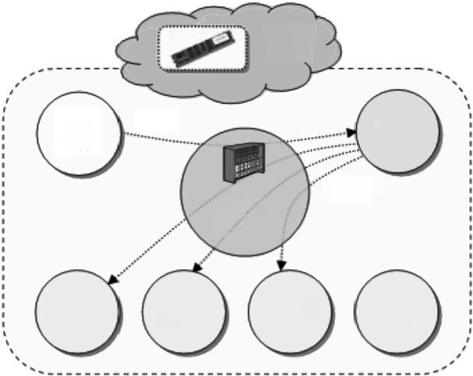
Memory sharing

Deputy element

Searching
Resource
meta-info

Memory Memory Memory
element element element
Memory element
User node

Fig.6.The architecture of memory sharing commonwealth.

Memory | User | Memory
element A | node | elementB
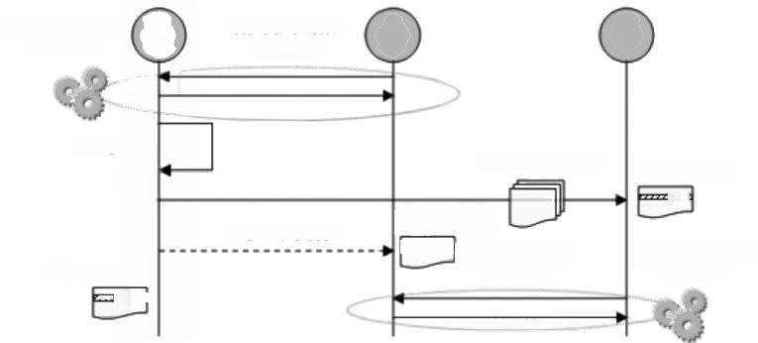
Memory sharing executor

Exception

Update status 2222zd
Service handover

Update status
zz Store and fetch the pages
Store and fetch the pages

Inform the user
Update status
2222

Memory sharing
executor
Fig.7.The autonomic collaboration process and the memory sharing executor.

In the process when the memory element A is providing memory service for a user node,the memory sharing executor includes the status set of A and the user node.When A detects the exception(such as the high usage of the resource in the host node),it satis- fies the local demand firstly due to its autonomy property.Therefore,A must withdraw
the corresponding memory service,and reserve the shared memory for local use.In this

698 Science in China Series F:Information Sciences

way,A follows the direction of the exception processing in the memory sharing executor, hands over the service to another memory element B,and informs the user through its intelligence and autonomy.After that,the status of the memory sharing executor changes, instead of the status ofA,the status of B is included in memory sharing executor.
In the above example,the autonomic collaboration mechanism is an important part in memory sharing process.The iVCE for Memory takes memory sharing executor as the basic unit for the collaboration transaction management,it implements the coordination of the autonomy for each unit and the collaboration among multiple units,and builds the dynamic and configurable base for the aggregation and the collaboration of the resources.

6 Related work
In this section,we will give a brief review of related work to the iVCE,such as grid computing,service-oriented computing,P2P computing and autonomic computing,etc.
6.1 Grid computing
The concept of grid computing⁰]was proposed in the middle of 1990s,and its goal is to efficiently integrate various geographically-distributed Internet resources to provide integrated services for users.In the past ten years,many projects for grid computing have been launched,such as TeraGrid,DataGrid and e-Science,to explore the methods to build a new computing environment on the Internet.Afterward,the OGSA (Open Grid Services Architecture)!]and the WSRF specification¹²]combine grid computing with web services.Recently the virtual machine technology becomes increasingly popular, and it is used for grid resource virtualization at the system level to accelerate the seam- less expansion of current existing application software to grid environments.This further promotes the development of grid computing.For example,the virtual workspace¹3]has become a successful coalescence of grid computing and virtual machine technology.
The ideas and goal of the iVCE are similar to those of grid computing.However,there are deficiencies in the basic theoretical research of grid computing now,especially in the following aspects,e.g.,the publication and organization of large-scale resource informa- tion in the open uncertain environment,on-demand dynamic acquirement and manage- ment of resources,the autonomy and intelligence of collaboration behavior,and dynamic service composition and selection.There have been considerable advances in the re- source virtualization of the virtual workspaces in grid environments,but it is still quite difficult to realize large-scale and extensive resource aggregation and collaboration. Starting with the basic theory and system-level mechanisms,the research of the iVCE, attempts to bring theoretical breakthrough to the above challenging problems,and its results will accelerate the research of grid computing and other network computing tech- nologies.Meanwhile,the iVCE also tends to enable resources sharing among multiple grid systems to realize resource aggregation and collaboration in the broad scope.
6.2 Service-oriented computing
With the development of web services,service-oriented computing(SOC)¹4]is be-

Internet-based virtual computing environment (iVCE):Concepts and architecture 699

coming the mainstream paradigm to construct distributed applications in the open net- work environment.SOC is a computing paradigm with the service as the basic element for application development,and its research focuses on the self-description,implemen- tation independency and accessibility,etc.
SOC focuses on such problems as interactions among different resources in heteroge- neous network environments,service choreography and orchestration.Compared with the web service,autonomous elements of the iVCE have different characteristics.
(1)The iVCE encapsulates the elements with abilities on autonomy.Based on the sensor and executor,the autonomic element with the knowledge state and behavior pol- icy can “explicitly”support autonomic decision through the analysis of the internal states and knowledge,while the web service have no the ability now.
(2)The iVCE puts more attentions on the interior construction and the implementing technologies.The two control policies specify the interior design pattern of autonomous elements.SOC seldom cares about the interior implementation technology of the service.
6.3 Peer-to-Peer computing
Peer-to-Peer (P2P)computing[15]is an important network computing paradigm that is different from the client/server computing and it has become very popular recently.All nodes participating in P2P computing act as equal peers and share resources and services by direct communications.Many P2P applications have been developed in various fields, such as cooperative work,search engine,file sharing,distributed storage and applica- tion-level multicast,etc.
Resource publication and organization is the core technology of P2P computing and it is the foundation to construct P2P networks and applications.Current P2P systems can be divided into three categories based on the structures of resource organization:centralized, unstructured and structured.The research topics of various P2P networks and applica- tions mainly include resource models,resource location and search mechanisms,routing algorithms,incentive mechanisms and the computational properties,etc.
Some key technologiesl16-18]of P2P computing may provide the iVCE the important enabling techniques,such as the publication and location technologies of self-organiza- tion resource,resource sharing incentive technologies,reputation technologies,etc. However,the research of P2P computing usually aims at specific applications and fo- cuses on specific application-oriented problems.They seldom care about the fundamental problems,e.g.,the architecture of the network computing environment.
6.4 Autonomic computing
Autonomic computing[19 is proposed mainly aiming at the challenging problems in the management,maintenance,security protection,and optimized schedule of the large-scale computing systems,especially distributed computing systems.The goal of the autonomic computing is self-configuration,self-optimization,self-protection and self-recovery of the distributed systems.Although the goal of autonomic computing is different from that ofthe iVCE,the iVCE can borrow the valuable ideas and technologies on resource management from it.Recently,the combination of autonomic computing and

700 Science in China Series F:Information Sciences

network computing is also an important research topic,e.g.,AutoMate¹9.
6.5 Other work
There is much other work related to the iVCE,such as network behavior[20,software agent²1-23,distributed trust management 24,25,semantic web[26,27,etc.The iVCE can refer to the valuable technologies from them,such as the behavior law of networked re- source,autonomic management of software systems,trust mechanism and intelligent processing.

7 Conclusions
The intrinsic characteristics of the Internet environment and its resources have brought grand challenges to construction of the network computing environment.The traditional computation theories,methodologies and technologies can no longer be applied to the emerging problems.Therefore,the requirement of breakthroughs in the novel mecha- nisms of the computing environment has become the academic and industrial consensus. The iVCE reflects our efforts to deal with these challenges.It attempts to utilize the con- cepts of autonomic element,virtual commonwealth and virtual executor and supports on-demand aggregation and autonomic collaboration in the open Internet environment to provide harmonious,trustworthy,and transparent integrated services for end-users and applications.The viability of the architecture model of the iVCE has been confirmed by the preliminary practices⁹,28,29JofiVCE.
Acknowledgements The authors are grateful to all members of the 973 project“Research of aggregation and collaboration mechanisms in the virtual computing environment"for discussions on the topics covered here and would like to give special thanks to Prof.Xinjun Mao,Dr.Dong- sheng Li and Mr.Rui Chu for their specific contributions to the presentation of the paper.This work was supported in part by the National Basic Research Program of China(973)“Research of aggregation and collaboration mechanisms in the virtual computing environment”(Grant No. 2005CB321800).

References
1 Clery D,Voss D.All for one and one for all.Science,2005,308(6):757-757
2 Hoffman D,Novak T,Venkatesh A.Has the Internet become indispensable?CACM,2004,47(7):37-42
3 Berners-Lee T,Hall W,Hendler J,et al.Creating a science of the Web.Science,2006,313(11):769-771
4 Gong L.Jxta:a network programming environment.IEEE Internet Comput,2001,5(3):88-94
5 Licklider J C R.Memorandum for members and affiliates of the intergalactic computer network.Advanced Research Projects Agency,Washington DC,USA,1963
6 Andrew ST.Distributed Operating Systems.New Jersey:Prentice Hall,1999
7 Wang HM.Middleware in Internet age.In:Proc of 2002 Euro-China Co-operation Forum on the Information Society.Beijing,China,April,2002
8 Redlich J,Suzuki M,Weinstein S.Distributed object technology for networking.IEEE Commun Mag,1998, 26(8):100-111
9 Chu R,Xiao N,Zhuang Y Z,et al.A distributed paging RAM grid system for wide-area memory sharing.In: Proc of IEEE IPDPS 2006.Rhodes Island:IEEE Computer Society,2006
10 Foster I,Kesselman C,Tuecke S.The anatomy of the grid:enabling scalable virtual organizations.Int JHigh

Internet-based virtual computing environment (iVCE):Concepts and architecture 701

Perform C,2001,15(3):200-222
11 Foster I,Kesselman C,Nick J,Tuecke S.Grid services for distributed system integration.Computer,2002, 35(6):37-46
12 Humphrey M,Wasson G,Jackson K,et al.State and events for Web services:a comparison of five WS-resource framework and WS-Notification implementations.In:Proc of IEEE HPDC-14,Research Trian- gle Park:IEEE Computer Society,2005,24-27
13 Keahey K,Foster I,Freeman T,et al.Virtual workspaces in the grid.In:Proc of 11th International Euro-Par Conference.Berlin:Springer-Verlag,2005
14 Papazoglou MP,Georgakopoulos D.Service-oriented computing.CACM,2003,46(10):25-28
15 Schoder D,Fischbach K.Peer-to-peer prospects.CACM,2003,46(2):27-29
16 Balakrishnan H,Kaashoek MF,Karger D,et al.Looking up data in P2P systems.CACM,2003,46(2):43-48
17 LiD S,Lu XC.A novel constant degree and constant congestion DHT scheme for peer-to-peer networks.Sci China Ser F-Inf Sci,2005,48(4):421-436
18 Feigenbaum J.Distributed algorithmic mechanism design:recent results and future directions.In:Proc of the 6th International Workshop on Discrete Algorithms and Methods for Mobile Computing and Communications. New York:ACM Press,2002.1-13
19 Kephart JO,David M C.The vision of autonomic computing.Computer,2003,36(1):41-50
20 Albert R and BarabasiAL.Statistical mechanics of complex networks.Rev Mod Phys,2002,74(1):48-97
21 Excelente-Toledo C B,Jennings N R.The dynamic selection of coordination mechanisms.J Auto Agnt Mult Sys,2004,9(1-2):55-85
22 Zhu H,Greenwood S,Huo Q,et al.Towards agent-oriented quality management of information systems.In: Proc of Workshop Notes of Second International Bi-Conference Workshop on Agent-Oriented Information Systems(AOIS-2000)at AAAI'2000,Austin,USA.New York:ACM Press,2000,57-64
23 Zambonelli F,Omicini A.Challenges and research directions in agent-oriented software engineering.Auto Agnt and Multi Syt,2004,9(3):253-283
24 Friedman B,Kahn PH Jr,Howe DC.Trust Online.CACM,2000,43(12):34-40
25 Blaze M,Feigenbaum J,Lacy,J.Decentralized trust management.In:Proc of 1996 IEEE Symposium on Se- curity and Privacy.Oakland:IEEE Computer Society,1996,164-173
26 Benatallah B,Dumas M,Fauvet M C,et al.Overview of some patterns for architecting and managing com- posite web services.ACM SIG Exch,2002,3(3):9-16
27 Hendler J.Science and the semantic web.Science,2003,299:520-521
28 LiD S,Cao JN,LuXC,et al.Delay-bounded range queries in DHT-based systems.In:Proc of IEEE ICDCS 2006,Lisboa:IEEE Computer Society,2006
29 Wang J,Shen R,Zhu H.Towards an agent oriented programming language with caste and scenario mecha- nisms.In:Proc of 4th International Joint Conference on Autonomous Agents and Multiagent Systems (AAMAS 2005).New York:ACM Press,2005

